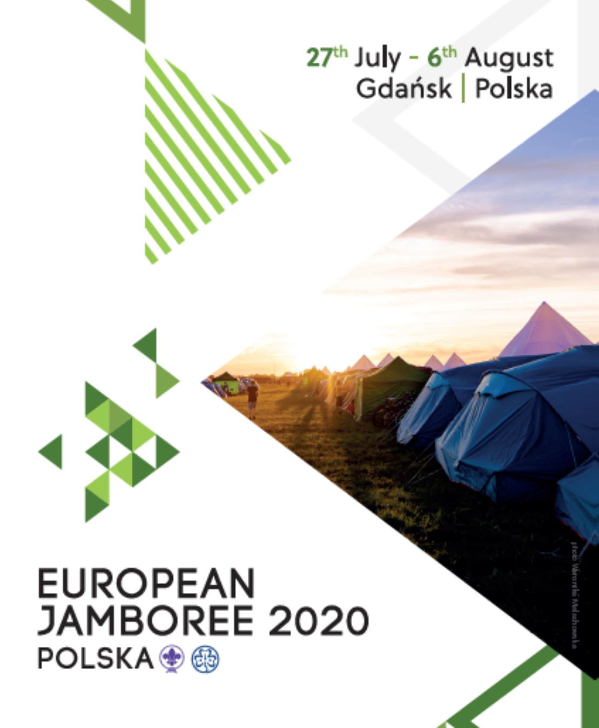

Introduction
The European Jamboree

After a gap of nearly 15 years, since the UK hosted the last European Jamboree in 2005, the upcoming European Scout Jamboree will take place in Poland from 26 July 2020 to 6 August 2020. Building on the fantastic programme developed as part of their World Scout Jamboree bid, the Scout and Guides of Poland invite you to join them for 11 days of activities, combining the chance to develop new skills, make new friends from across Europe and experience Poland’s beautiful countryside. Based on its own island close to the city of Gdansk, the purpose built site is within walking distance of beautiful sandy beaches, pine forests and a short bus ride from the bustling city.

Sobieszewo is a unique district of the city of Gdańsk, surrounded by the Śmiała Wisła river on the West, the Martwa Wisła river on the South, the Przekop Wisły on the East (all of these being branches of the longest Polish river, the Vistula – Wisła) and to top it all, the Bay of Gdańsk on the Baltic Sea on the North. The Island is a part of the Mierzeja Wiślana.
Sobieszewo Island is an area of about 35 km2 with more than 1000 hectares of woods. The beach, 11 kilometres long, is the longest one in Gdańsk. It includes two guarded bathing areas – in Sobieszewo and in Orlinki.

On the Island there are two nature reserves: Ptasi Raj (Birds’ Paradise) on the western end of Śmiała Wisła and Mewia Łacha (Seagull Dune) on the East, near Przekop Wisły. As an act of recognition of Sobieszewo Island’s natural beauty and unique value, the area has been granted the status of a legally protected nature park.

As a County, we have committed to taking a Unit consisting of 4 leaders and 4 patrols of 9 young people. We are also taking 5 International Service Team (IST) leaders who will be helping as International Service Team members, these will be selected at a separate time.
The cost of the event is considerably lower than that of the World Scout Jamboree at 1850PL per person, this includes the Jamboree event, food whilst at the event, Unit equipment will contain all necessary equipment for four patrols (36 participants and 4 adult leader) to cook their food. Every unit will also get a dining shelter to share so that they will have a natural meeting point in their camp, as well as other camping equipment such as tables and benches.

Items not included and needed to be added to the base Jamboree cost

- plates, drinking cups, cutlery
- polo shirt, hoodie
- uniform shirt/unit necker
- sleeping bags
- tents
- travel/transport
- pre/post Jamboree activities/travel/accommodation
- insurance
- training camps

Considerations
The following will be considered when selecting leaders to attend European Jamboree:
- Interest in World Scouting.
- Ability to work in a team.
- Commitment to Scouting.
- Commitment to the Jamboree experience including training events.
- Communication Skills (including listening to instructions).
- Ability to take responsibility for oneself and 9 young people.
- Ensuring the impact the Jamboree experience will have on the young person.

The Jamboree is a physically, mentally and emotionally demanding experience. Applicants should be aware that the Jamboree experience will last 1½ weeks+ and so must be sure that they have the support of their family to be able to commit to the event. There will also be a number of weekend commitments in preparation for the journey and they should be confident that they have the time available to commit to these also.

It is recognised that the youth participants within a Unit span an age range of 4 years. It is not expected that all can perform at the same level, age is a legitimate consideration and leaders will need to take this into consideration.

Application for
Deputy Unit Leader/Assistant Unit Leader
Greater Manchester West Unit to European Jamboree in Gdansk, Poland 2020.
This application must be completed electronically and emailed.
Please indicate your role preference in order or no preference
 | Deputy Unit Leader |  | Assistant Unit Leader |  | No preference

Section1: PERSONAL INFORMATION
Name: |  | Known as:
Address:
 |  | Home phone:
 |  | Mobile phone:
 |  | Email address:
Occupation: |  | Date of birth:
Current Scouting Appointment: |  | Scout Group:
 |  | District:
Brief history of your Scouting/ Guiding or other relevant voluntary experience
Other hobbies/ interests:

Section 3: APPLICATION
Please use this space to describe why you are applying for the role and what you can bring to the team. The role description and person specification should be used as guidance and prompts.
We would like to understand what has motivated you to apply and what you could bring to the team and the Jamboree experience for the young people in the Unit. How will you ensure that you will make this experience Youth shaped? Use this space to sell yourself, and to explain what relevant experience you have of the age range and how your camping, practical, administrative, management or other skills would be useful to the team. This section must not exceed two sides of A4 (in standard type!)
Section 4: REFERENCES
Please write the name, phone number and email address of two referees who can support your application. Your referees should know you well, but not be related to you. Both should be connected to you though Scouting so they can comment on your Scouting experiences. Please indicate each referees Scouting role and also that they know you have added them as referees.
Referee 1: |  | Referee 2:
This form must be returned to jeff.picton@gmwscouts.org.uk no later than midnight on Sunday 7th April 2019.
LATE APPLICATIONS WILL NOT BE CONSIDERED. We will acknowledge receipt of your application within 24hrs, if you have not heard back then please do contact us.

