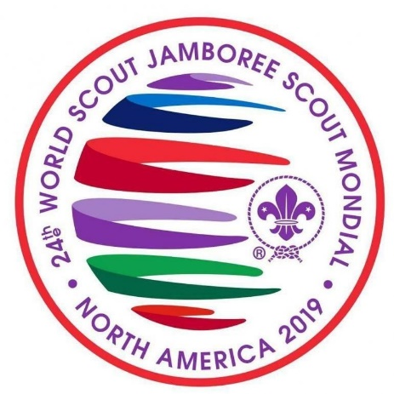

Unit Leader – Greater Manchester West Scouts to 24th World Scout Jamboree

Responsible to: Andy Farrell County Commissioner / Jeff Picton ACC (I)
Responsible for: Deputy Unit Leader
Assistant Unit Leaders (x2)
Youth participants
Main Contacts: County/Area/Region Commissioner and Deputies or equivalents
Internal: Unit Leadership teams of other Jamboree Units
Assistant County/Regional/Area Commissioners
County Media Team
County/Area/Regional Advisers and Scouters
District Commissioners (or nominees)
Events Team
UK Contingent Leader
UK Contingent Management &Support Team
External: Parents/Carers of young people in Unit
Sponsors and supporters of the Jamboree Unit
Media contacts (in partnership with County Media Development
Role Summary: To lead and manage a Jamboree Unit attending the 24th World Scout Jamboree.
To uphold and enact the values of Scouting (care, co-operation, belief, respect and integrity) at all times.
To promote and safeguard the welfare of young people by following the Yellow Card at all times.
To be committed to and have an understanding of diversity and equality.

UK Contingent Vision: To deliver a unique international adventure shaped by young
people, where contingent members will develop personally and have a positive longer term
impact on Scouting and beyond.

Main Activities:
- To attend the World Scout Jamboree in North America and be responsible for the safety and operation and wellbeing of the Unit.
- To manage and mentor the development of the Unit leadership team.
- To engage with the UK Contingent team to support a youth shaped experience and ensure personal development goals for the Unit are met.
- To set and monitor budgets and manage the finances of the Unit within guidelines set by the County/Area/Region (with appropriate support).
- To have completed the Wood Badge or achieved a reasonable amount of development as agreed with the GMWSC and UK Contingent.
- To ensure that all members of the Unit (Leaders and Participants) develop new skills (both hard and soft) that will allow them to take back for the benefit of the local Scouting and their wider community.
- To be involved in the process of selecting youth participants for the Unit.
- To ensure that the experience is “Youth Shaped” and that participants are involved in decision making at all levels.
- To be the main contact for the UK Contingent and to pass on information about the UK Contingent’s preparations.
- To attend UK Contingent event (training days, weekends, etc.) and to work closely with UK Contingent Team members in order to ensure all relevant Unit preparations and administration meet deadlines.
- To work with, and possibly mentor, local members of the International Service Team to allow them to integrate into the Unit experience (this relationship can pay dividends if the Unit needs extra help or support during the Jamboree).
- To communicate all relevant information about the Jamboree to relevant parties (e.g. other Unit Leaders, young people and their parents/carers, County/Area/Region team, etc.).
- To ensure a programme of activity, training and team building (including weekend camps and other Unit events) is developed for the Unit and leadership team to build a functioning and cohesive team in time for the Jamboree.
- To encourage fundraising by the young people in the Unit.
- To ensure the production of a visual identity (in accordance with UK Contingent guidelines) and “merchandise” for the Unit (if desired); i.e. t-shirts, badges, etc; in partnership with other Unit Leaders and young people.
- To ensure that a member of the team works with the Contingent Management Team Member (Communications) and the County Media Team to identify Unit stories and make full use of the publicity generated from the Jamboree.
- To ensure that a member of the team liaise with the County Media Team to create appropriate communication tools (i.e. email lists, forums, blogs, websites, etc).
- Contribute to the review and feedback process as required.
- Undertake regular reviews with their County/Area/Region team to ensure the expected level of development is achieved by the Unit.
- To uphold and enact the values of Scouting (care, co-operation, belief, respect and integrity) at all times.
- Promote and safeguard the welfare of young people by following the Yellow Card at all times.
- To demonstrate commitment to and understanding of diversity and equality.
- Any other duties as may be reasonably requested by the County / Area / Regional Commissioner (or nominee) and the Contingent Leadership Team

