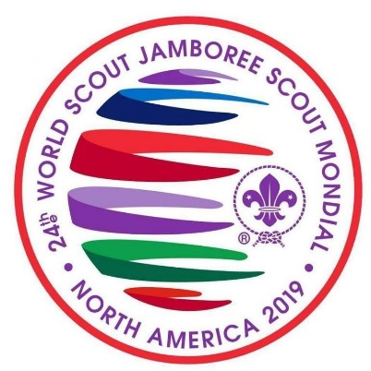
Information Letter

Dear Colleague,

We hope that you will consider applying for a position in the leadership teams for the Greater Manchester West Unit that will be attending the 24th World Scout Jamboree to be held in North America in 2019.

There are 4 Leader positions available (1 Unit Leader, 1 Deputy Unit Leader and 2 Assistant Unit Leaders) these roles will help the Unit to achieve the best experience possible.

We are sure that a large number of adults will want to take part in this event as a Unit Leader and so a role description and person specification has been produced to highlight what the role entails and the skills and experiences we are looking for to ensure we can deliver a unique experience for the young people attending.

The selection panel are keen that every adult in Greater Manchester West that wants to apply should do so, and consider the Jamboree experience a development opportunity for adult volunteers, as much as for young people.

The information you provide within your application form will form the basis on which to make a decision about inviting you to an interview. The interview process will be short and friendly – we want to find out about you and why you want to go to the Jamboree, listen to some of your experiences in and out of Scouting, and to understand what you would bring to a leadership team.

We anticipate there will be a large number of applications for the roles.

We are planning on offering 3 options for interview and you are asked to indicate on your application form which date/ time/ location you prefer. If invited to interview we will try and give you your top preference, but please try and keep at least the first two options free until we confirm. The options will be:

19th June Monday @7.00pm onwards
20th June Tuesday @ 7.00pm onwards
26th June Monday @ 7.00pm onwards
27th June Tuesday @ 7.00pm onwards

Following on from the interview if successful we will ask you to participate in another event: the purpose of which will be to learn more about your team working and leadership skills and how you work with young people of an Explorer Scout age range. Therefore please keep 8th- 10th September free to participate in the event.

If these dates pose problems for you please speak to Jeff Picton (jeff.picton@gmwscouts.org.uk)

Time line for applications is as follows:

20th May | Application form etc published.
9th June | Deadline for receipt of applications.
11th June | Notification to applicants whether they are invited to interview
19th, 20th, 26th, 27th June | Interviews
14th July | Confirm invitations to selection event
8th – 10th September | Selection Event
11th September | Notify applicants whether they have been selected as part of the Unit Leadership Team

The selection process is being run by Jeff Picton ACC (I), Andy Connellan DDC Programme, Lewis Foster CYC. If you have any questions about the process you are very welcome to contact any of the team.

Please note the deadline for applications is 9th June 2017. All applications must be submitted by email to wsj2019@gmwscouts.org.uk and you will receive confirmation that this has been received within 48 hours. Unfortunately, applications submitted after this deadline will not be considered. If you don’t hear from us within 48 hours of submitting your application please phone 07907545798 and double check.

We do hope that you will apply to join our Jamboree team and contribute to ensuring the young people in the Greater Manchester West Unit to the World Scout Jamboree have the best possible experience.

We look forward to receiving your application soon. Good luck!

Andy Farrell Jeff Picton
County Commissioner ACC International

