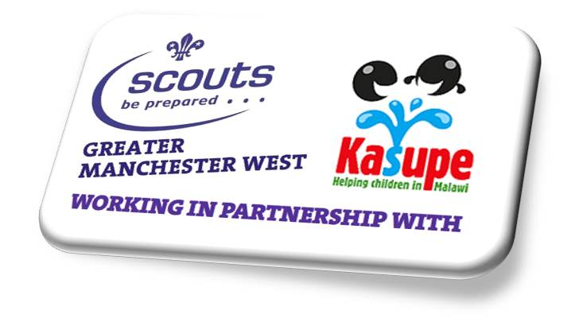

Project Malawi2018 Community Development Participant Application

Outline: To be part of a group of 16-25 year olds in carrying out a community development project & expedition to Malawi in the Summer 2018, the participants should be available for at least 5 of the 8 training weekends, support fundraising events and to able to assist the project leadership team to ensure a successful expedition.
Responsible to: Project leadership team
Main contacts: Project Leader, Leadership team, ACC International, Explorer Scouts, Network Scouts,
Other contacts: County Commissioner & Deputies, County Youth Commissioner & Deputies, ACC Explorers. ACC Network, Scout Leaders of Host country
Requirements: Understand and accept the Scout Association’s Policies; either a young person member or adult member of the Scout Association and scout within Greater Manchester West Scout County; hold a satisfactory DBS clearance (if over 18); be computer literate and use email and social media such as Facebook, WhatsApp -to help with communication both internally and externally to the project.
What is required?
The participants will work as part of the team and independently to achieve the following: ~
- To include
  - Travel to and from the country
  - Travel within the country
  - Accommodation both at home and on project
  - Food for training weekends and on project
  - Kit requirements
  - Project requirements such as design and materials etc.
- The selection of the mini events whilst In Country
- Take part in appropriate training on training/service weekends
- Attend regular leader/participant/parent/guardian meetings
- Promote achievement both inside and outside of Scouting in GMW and the UK
- Develop links with scouts of the Host country for future expedition/projects
- Create, develop and support fundraising opportunities for all of the team members
- Promote the expedition in presentations post project

What we are looking for: ~
- Able to develop positive relationships both in a team and one to one
- Work well in meetings, with an ability to be diplomatic in your approach and able to bring new ideas to these meetings
- Willing to take a role that may require you to learn new skills
- Able to motivate others
- Be flexible
- Able to work well with other young people and to follow a leadership teams direction
- Be able to take on board other opinions and take a balanced view when they may not be all the same
- Be able to balance the project time demands with your scouting and education/work commitments
- Able to take 3 weeks leave from education/work and family commitments, the dates will be confirmed as soon as possible, but will be the end of July into early August 2018.

Application Dates
Your application needs to be completed and returned by Midnight on Friday 28th October 2016
All applications should be emailed to
Malawi2018@gmwscouts.org.uk
Interviews/Selection weekend will take place on 12th/13th November 2016 please be available on this weekend.
You will be emailed details of this weekend after your application has been received.
Thank You
Malawi Leadership Team

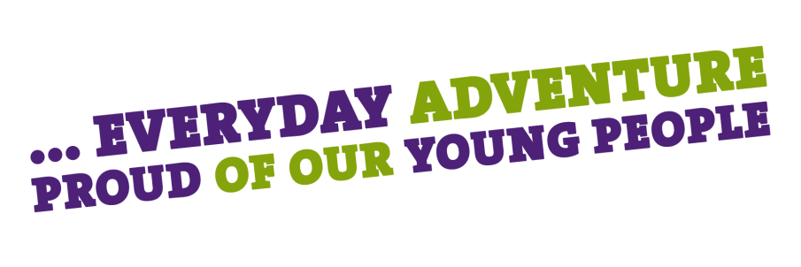

Greater Manchester West County Scout Council
G.M.W Scouts County Office, Unit 5 Kelmercourt House, 102 Sale Lane, Tyldesley, Manchester M29 8PZ
T: 0161 790 5634 E: county.office@gmwscouts.org.uk W: www.gmwscouts.org.uk
Registered Charity Number(s) 508002
Application Form for Project Malawi2018 Community Development Participant
Name:

DOB:

Gender:

Address:

Contact Number:

Email Address:

Scout Membership No. (if applicable)
Current Scout Appointment/Role & Group/Unit/District
Name of GSL/DESC/ESL or DC

Scouting Experience:
Please let us know why you are applying for this role (explain how your skills and experiences fit the role description above) or why you think this would benefit you and your scouting future.
Name………………..

Date…………..

